This course requires you to be comfortable with navigating the edX platform. If you are new to edX or online courses, please take the DemoX course, offered by edX. This demonstration course is free, takes about an hour to complete, and walks you through the features of edX.
Visit the edX Help Center if you need further assistance navigating or using the platform.
You can view your grades on the Progress tab.
Each week, we will have discussion forums where you can post questions about the material. The forums will be linked within each unit, or can be accessed from the Discussion tab. Our discussion enviroment is respectful and intolerant of cheating behaviors. Review the Honor Code Discussion Forum Guidelines in the Syllabus before posting.
Annotate
This course will use numerical input problems in practice and homework problem sets. Use the sample problem below to practice entering different kinds of numbers, including decimals, fractions and exponents. Review the edX documentation on entering numerical input for more information.
This sample problem is for you to learn how to use numerical input with edX. It is ungraded with many attempts.
Problem Options
The following options appear with problems.
- Save: This button saves your answer if you want to keep your answer but are not ready to submit it yet.
- Show Answer: Reveals the answer to a problem after you make an attempt. For the graded problem sets, you will have a limited number of attempts, which will appear next to each problem, and will not be able to see the answer until you have used up all of your attempts on homework problems.
- Reset: Clears out your answer before submitting a problem.
- Hint: Some problems offer a hint to help you solve them.
- Submit: Submits your answer for grading, and counts against your remaining attempts.
Annotate

To post math notation in the discussion forums, you can use LaTeX notation. LaTeX is a document processing system used to display technical notation. The edX platform supports the use of LaTeX notation in the discussion forums. To add LaTeX notation to your posts, enclose your LaTeX code in dollar sign “$” characters. If you are entering a longer equation, you do not need to enclose each individiual character in dollar signs, just the beginning and end. Here are some examples with frequently used symbols in this course:
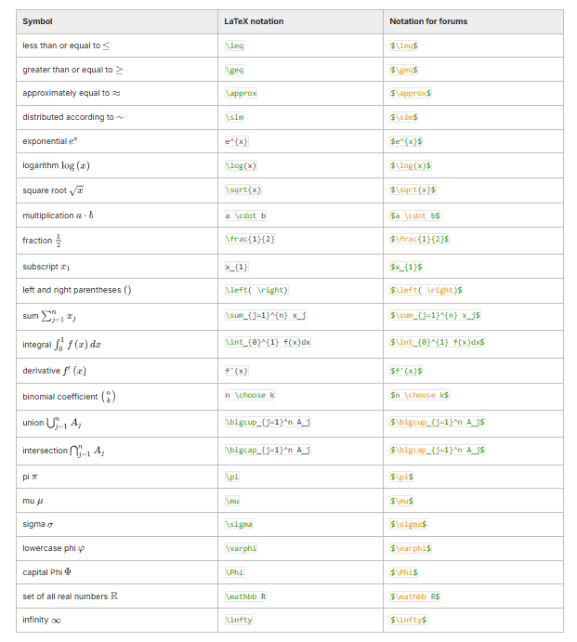
Use the practice forum below if you want to practice using math notation in the discussion forum before you post your "real" question. Note this is a practice forum and will not be monitored by staff.

The Story of Vandermonde
Each unit of the course will open with a story to motivate and build intuition for that unit's material. Our first story is a story about stories. Watch now as Colin and Sylwia, two students who are learning probability, unravel the mystery of Vandermonde's identity....

The moral of the story is to look for a story!
This unit introduces probability as a framework for studying randomness and uncertainty. From just a couple of axioms, many beautiful properties and countless useful applications flow. Many probability calculations require counting how many objects there are in a set, so this unit also introduces factorials, binomial coefficients, and some basic techniques for counting.
Binomial coefficients satisfy some neat identities, such as Vandermonde's identity, that often arise in probability. As the birds of East Vandermonde reveal to Colin and Sylwia, it is sometimes easier to understand these identities using a story rather than algebra or calculus. More broadly, we use stories throughout this course to gain insight into various concepts and their connections.
Learning Objectives
In this unit, you will:
- Learn a framework for thinking about random experiments
- Study the naive and general definitions of probability
- Explore techniques for counting how many objects are in a large set, such as the number of possible outcomes of an experiment
- Think about story proofs, which allow us to prove certain mathematical results (such as Vandermonde's identity) without resorting to tedious algebra or calculus

Unit 1: Probability and Counting
Adapted from Blitzstein-Hwang Chapter 1.
Mathematics is the logic of certainty; probability is the logic of uncertainty. Probability is extremely useful in a wide variety of fields, since it provides tools for understanding and explaining variation, separating signal from noise, and modeling complex phenomena. For example, probability is needed in:
- Statistics: Probability is the foundation and language for statistics, enabling many powerful methods for using data to learn about the world.
- Physics: Einstein famously said ''God does not play dice with the universe", but current understanding of quantum physics heavily involves probability at the most fundamental level of nature.
- Biology: Genetics is deeply intertwined with probability, both in the inheritance of genes and in modeling random mutations.
- Computer science: Probability also plays an essential role in studying randomized algorithms, machine learning, and artificial intelligence.
- Finance: Probability is central in quantitative finance. Modeling stock prices over time and determining ''fair" prices for financial instruments are based heavily on probability.
- Political science: In recent years, political science has become more and more quantitative and statistical, e.g., in predicting and understanding election results.
- Medicine: The development of randomized clinical trials, in which patients are randomly assigned to receive treatment or placebo, has transformed medical research in recent years.
- Life: Life is uncertain, and probability is the logic of uncertainty. While it isn't practical to carry out a formal probability calculation for every decision made in life, thinking hard about probability can help us avert some common fallacies, shed light on coincidences, and make better predictions.

Unit 1: Probability and Counting
Adapted from Blitzstein-Hwang Chapter 1.
The mathematical framework for probability is built around sets. Imagine that an experiment is performed, resulting in one out of a set of possible outcomes. Before the experiment is performed, it is unknown which outcome will be the result; after, the result ''crystallizes" into the actual outcome.
Definition 1.2.1 (Sample space and event).
The sample space S of an experiment is the set of all possible outcomes of the experiment. An event A is a subset of the sample space S, and we say that A occurred if the actual outcome is in A.

The sample space of an experiment can be finite or infinite. When the sample space is finite, we can visualize it as Pebble World, as shown in Figure 1.2.2. Each pebble represents an outcome, and an event is a set of pebbles. Performing the experiment amounts to randomly selecting one pebble.
Set theory is very useful in probability, since it provides a rich language for expressing and working with events. Set operations, especially unions, intersections, and complements, make it easy to build new events in terms of already-defined events.
Note
This course sometimes uses set theory notation. See the Set Theory Dictionary below if you need a refresher on set theory symbols, such as for union.
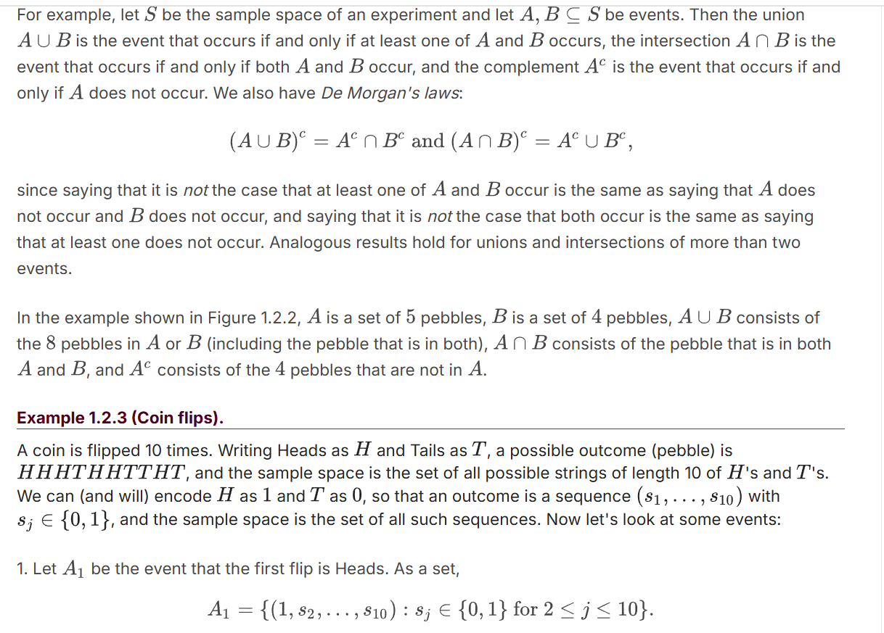

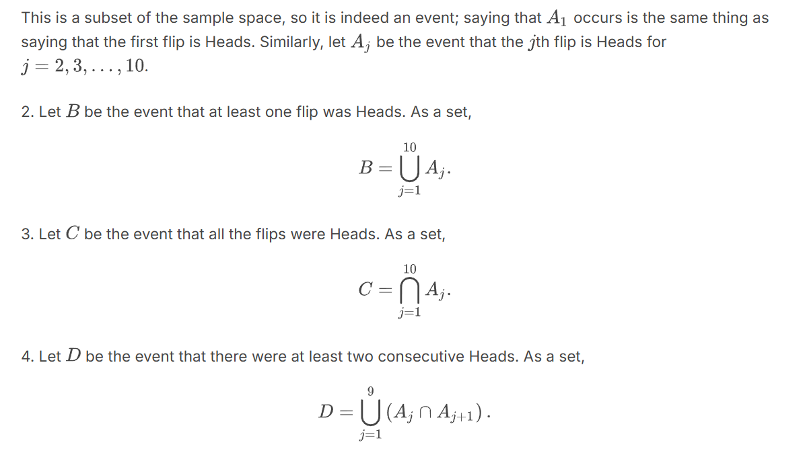
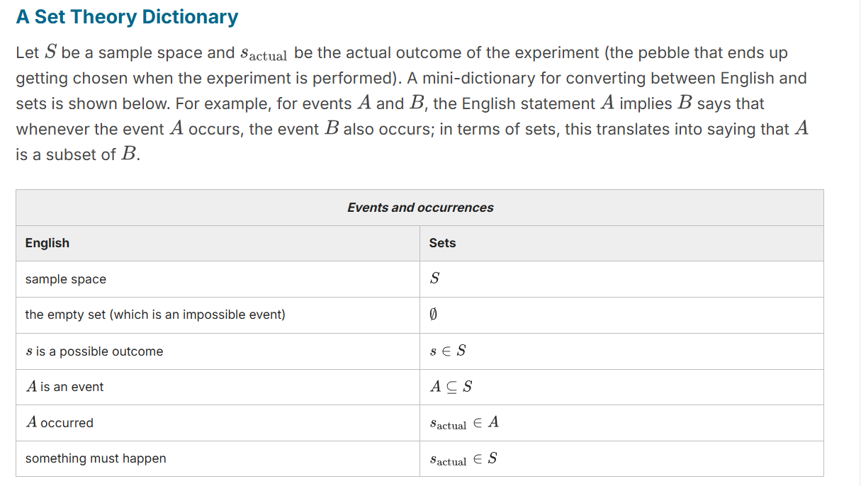
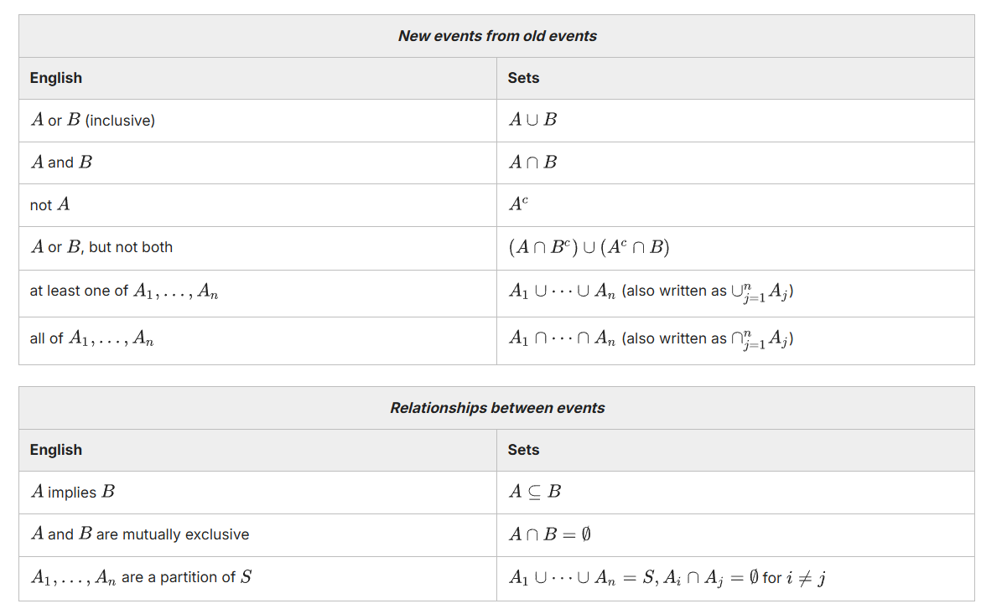

Unit 1: Probability and Counting
Adapted from Blitzstein-Hwang Chapter 1.
Historically, the earliest definition of the probability of an event was to count the number of ways the event could happen and divide by the total number of possible outcomes for the experiment. We call this the naive definition since it is restrictive and relies on strong assumptions; nevertheless, it is important to understand, and useful when not misused.
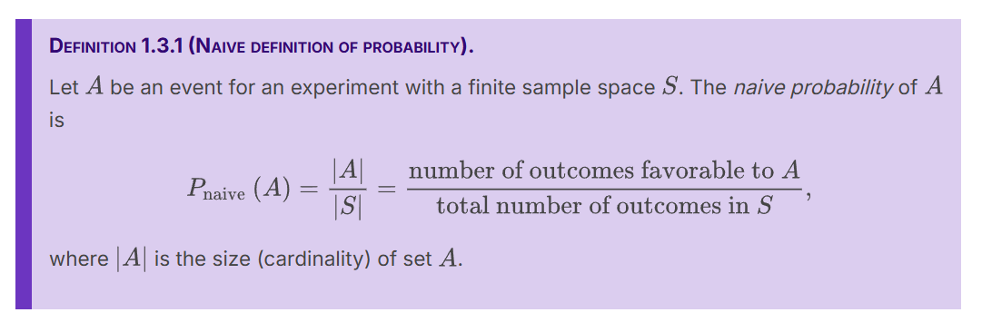

The naive definition is very restrictive in that it requires S to be finite, with equal mass for each pebble. It has often been misapplied by people who assume equally likely outcomes without justification and make arguments to the effect of "either it will happen or it won't, and we don't know which, so it's 50-50". For example, if we don't know whether or not there is life on Saturn, should we conclude that it is 50-50? What about intelligent life on Saturn, which seems like it should be strictly less likely than there being any form of life on Saturn? But there are several important types of problems where the naive definition is applicable, such as when there is symmetry in the problem that makes the outcomes equally likely.

Unit 1: Probability and Counting
Adapted from Blitzstein-Hwang Chapter 1.
Calculating the naive probability of an event involves counting the number of pebbles in and the number of pebbles in the sample space . Often the sets we need to count are extremely large, so it would be tedious or infeasible to count the possibilities one by one. To address this challenge, we will introduce a few techniques for counting.
Multiplication rule
In some problems, we can directly count the number of possibilities using a basic but versatile principle called the multiplication rule. We'll see that the multiplication rule leads naturally to counting rules for sampling with replacement and sampling without replacement, two scenarios that often arise in probability and statistics.
Theorem 1.4.1 (Multiplication rule).
Consider a compound experiment consisting of two sub-experiments, Experiment A and Experiment B. Suppose that Experiment A has a possible outcomes, and for each of those outcomes Experiment B has b possible outcomes. Then the compound experiment has ab possible outcomes.

Figure 1.4.2: Tree diagram illustrating the multiplication rule. If Experiment A has 3 possible outcomes and Experiment B has 4 possible outcomes, then overall there are possible outcomes.

Example 1.4.3 (Ice cream cones).
Suppose you are buying an ice cream cone. You can choose whether to have a cake cone or a waffle cone, and whether to have chocolate, vanilla, or strawberry as your flavor. This decision process can be visualized with a tree diagram, as in Figure 1.4.4.

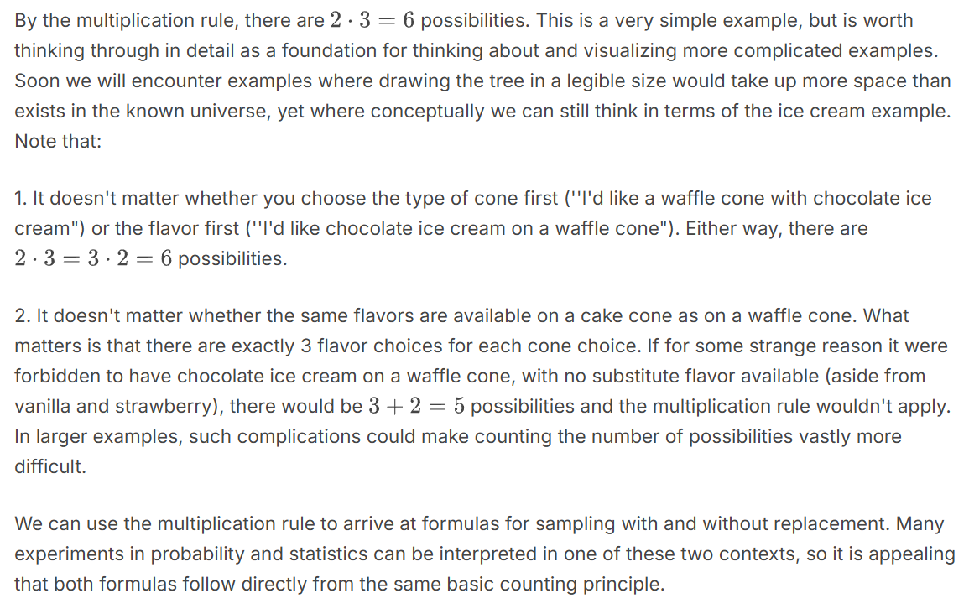

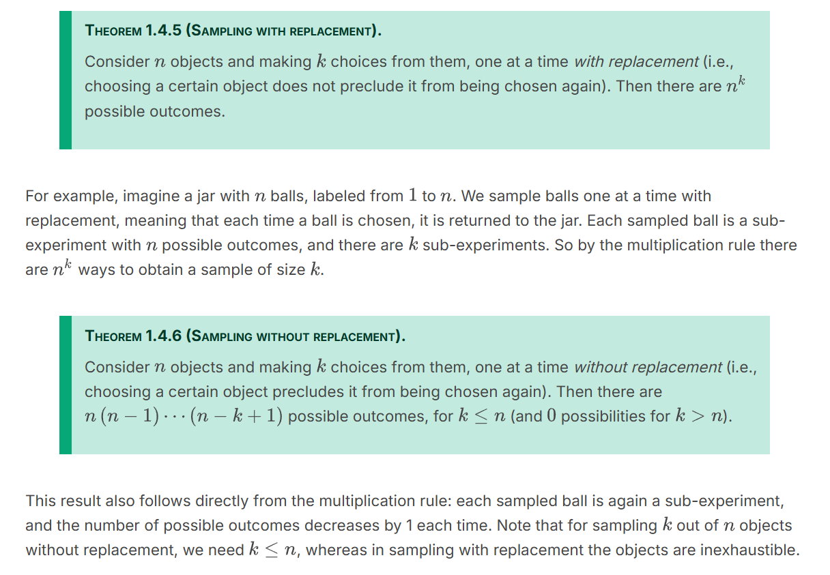

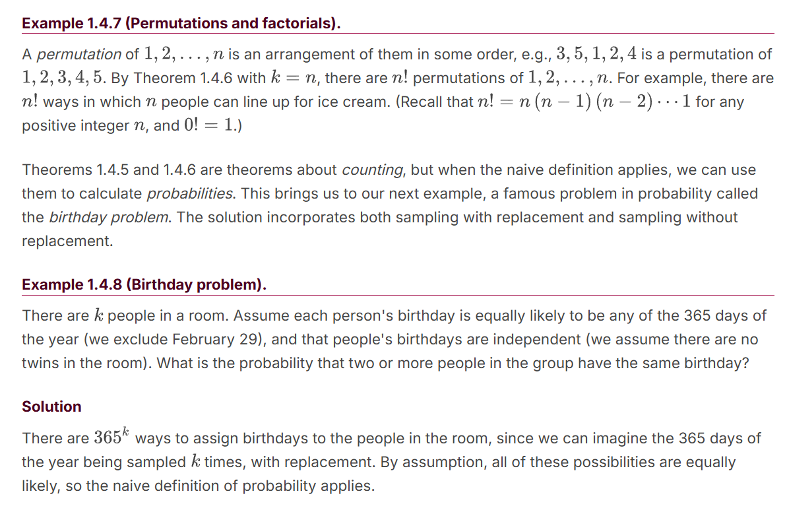
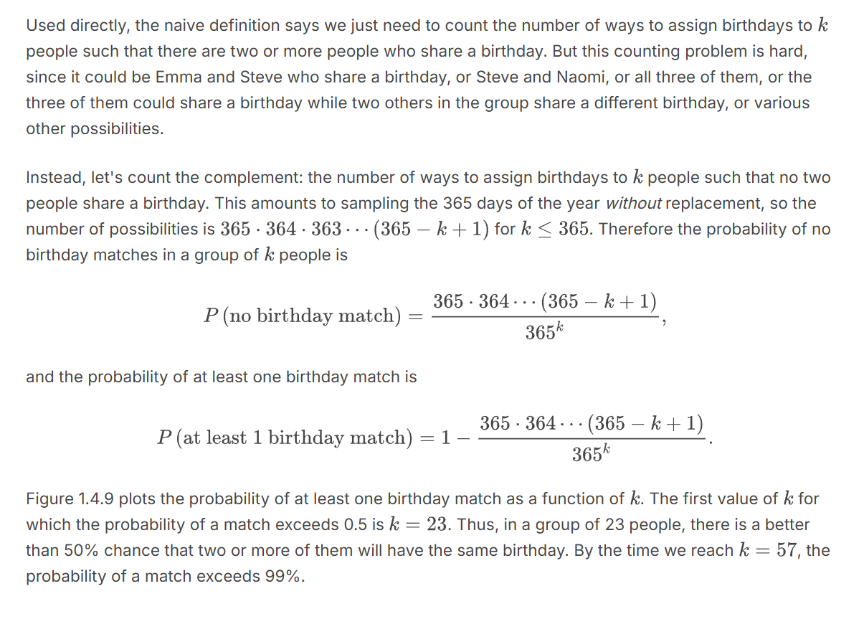
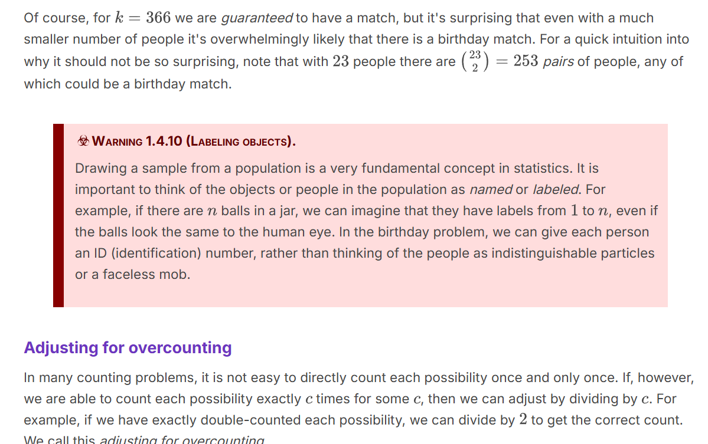
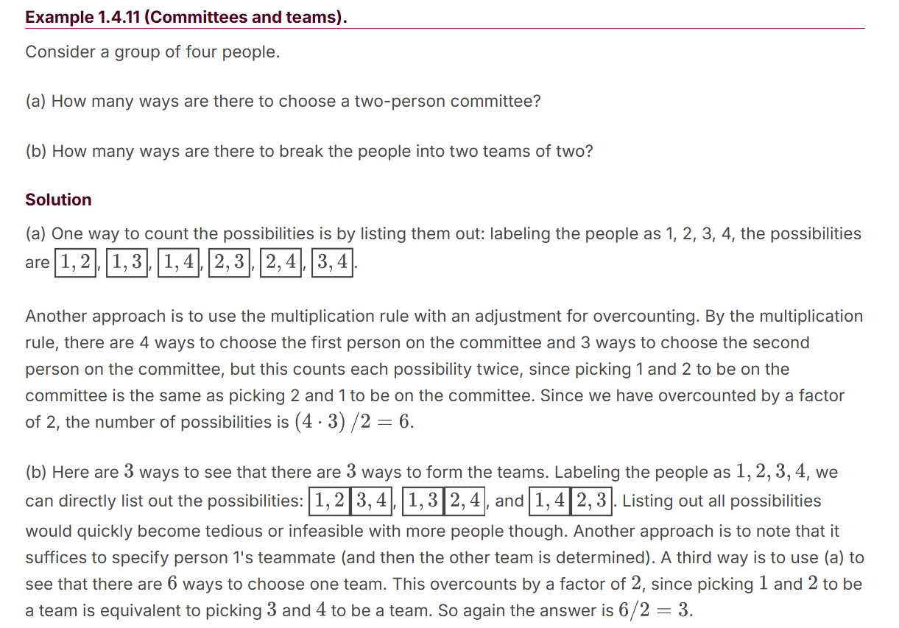
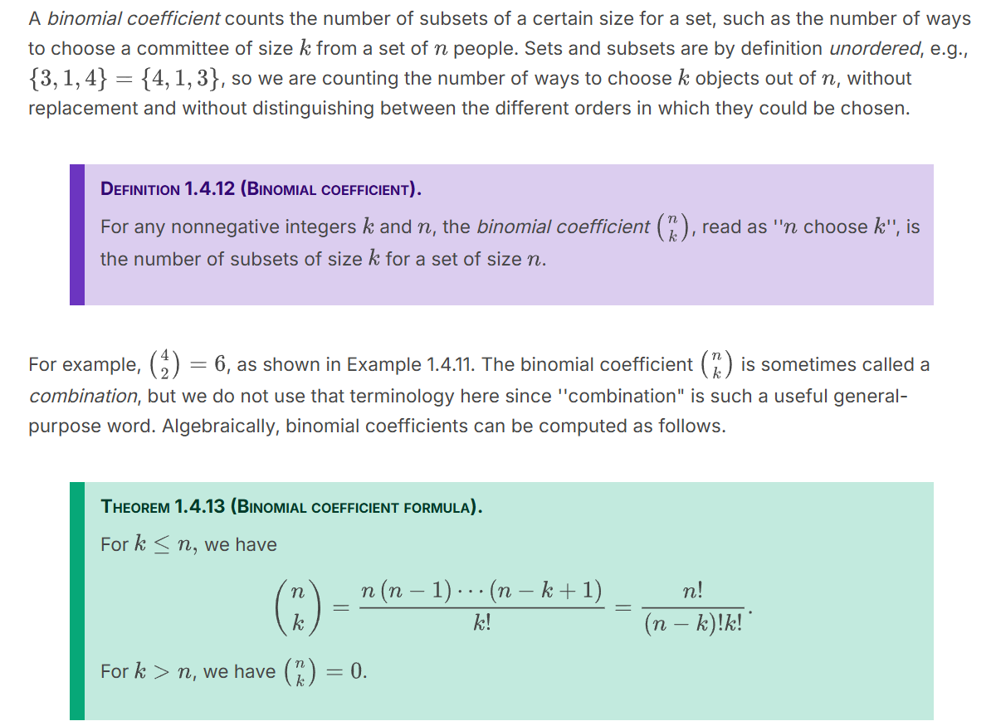
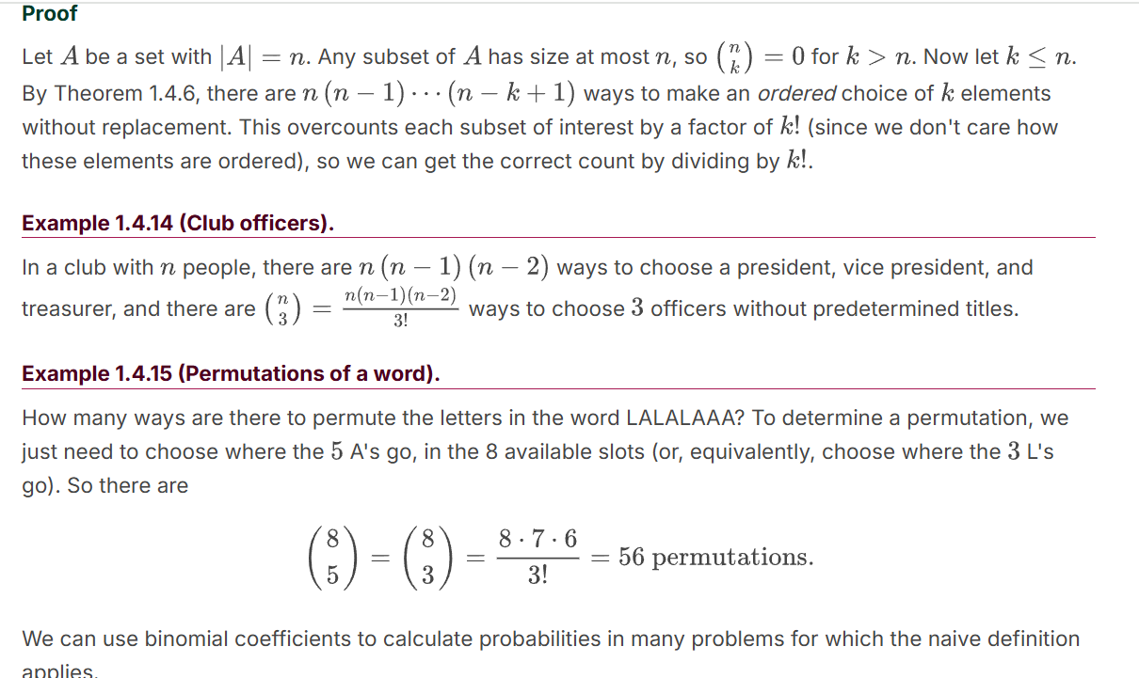
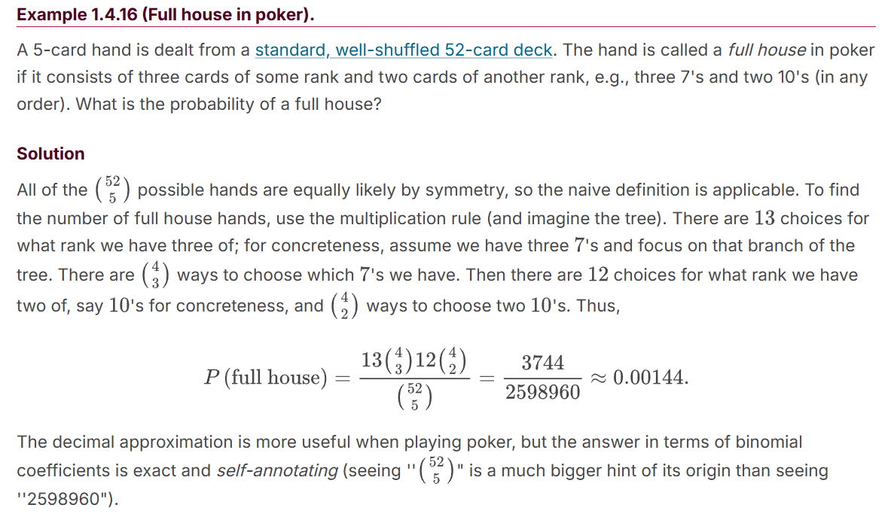

Unit 1: Probability and Counting
Adapted from Blitzstein-Hwang Chapter 1.
A story proof is a proof by interpretation. For counting problems, this often means counting the same thing in two different ways, rather than doing tedious algebra. A story proof often avoids messy calculations and goes further than an algebraic proof toward explaining why the result is true. The word ''story" has several meanings, some more mathematical than others, but a story proof (in the sense in which we're using the term) is a fully valid mathematical proof. Here are some examples of story proofs, which also serve as further examples of counting.
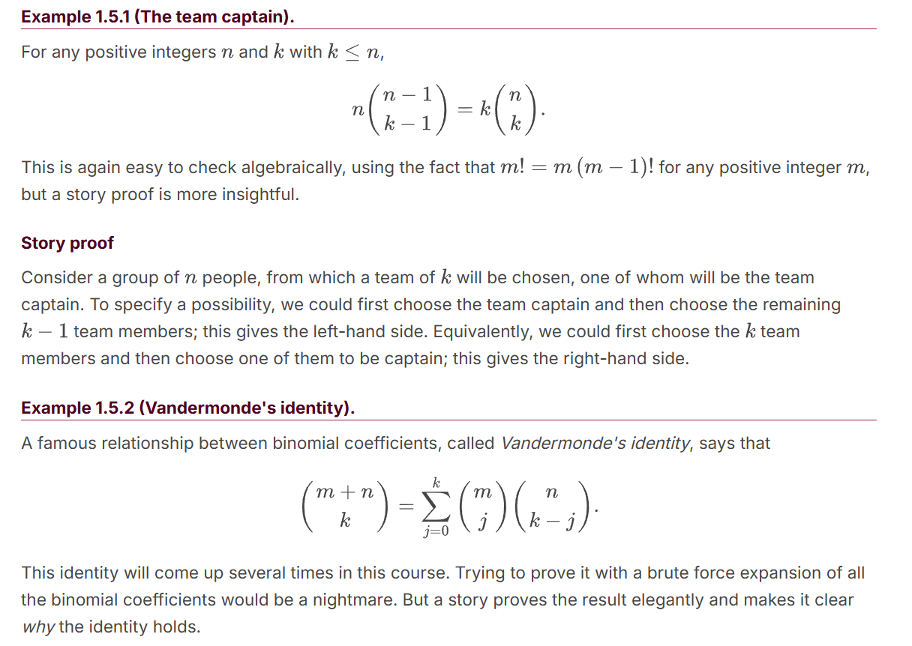
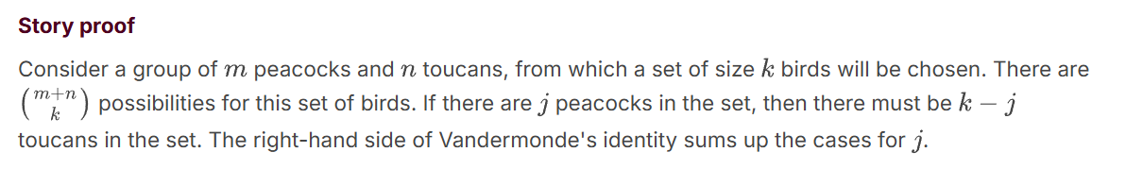

Unit 1: Probability and Counting
Adapted from Blitzstein-Hwang Chapter 1.
We have now seen several methods for counting outcomes in a sample space, allowing us to calculate probabilities if the naive definition applies. But the naive definition can only take us so far, since it requires equally likely outcomes and can't handle an infinite sample space. We now give the general definition of probability. It requires just two axioms, but from these axioms it is possible to prove a vast array of results about probability.

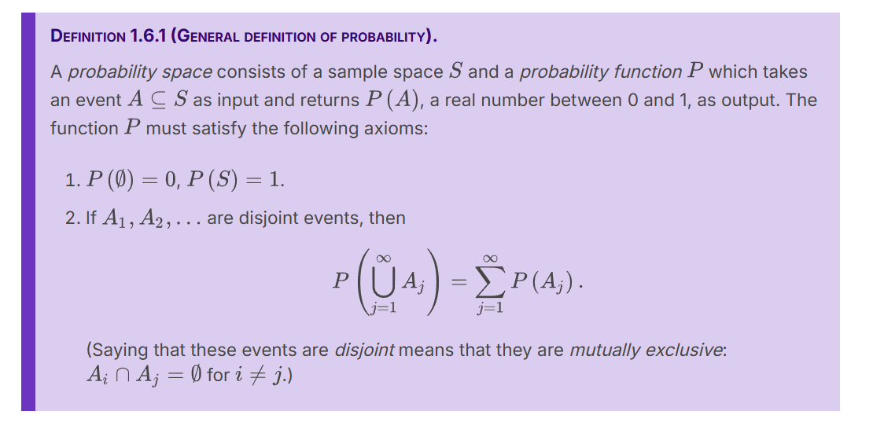

In Pebble World, the definition says that probability behaves like mass: the mass of an empty pile of pebbles is 0, the total mass of all the pebbles is 1, and if we have non-overlapping piles of pebbles, we can get their combined mass by adding the masses of the individual piles. Unlike in the naive case, we can now have pebbles of differing masses, and we can also have a countably infinite number of pebbles as long as their total mass is 1.
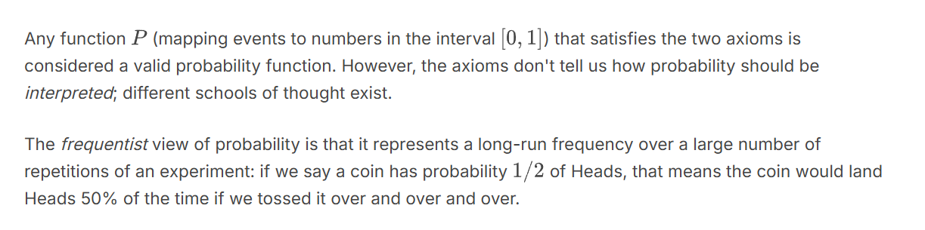
The Bayesian view of probability is that it represents a degree of belief about the event in question, so we can assign probabilities to hypotheses like ''candidate A will win the election" or ''the defendant is guilty'' even if it isn't possible to repeat the same election or the same crime over and over again.
The Bayesian and frequentist perspectives are complementary, and both will be helpful for developing intuition in later chapters. Regardless of how we choose to interpret probability, we can use the two axioms to derive other properties of probability, and these results will hold for any valid probability function.

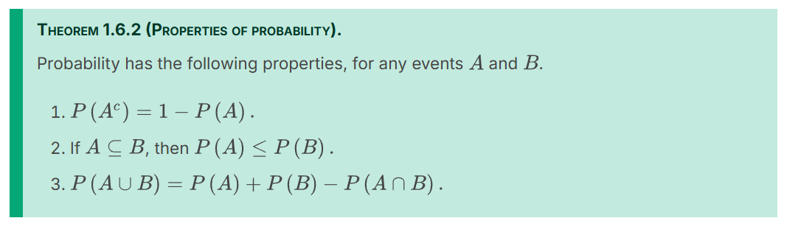

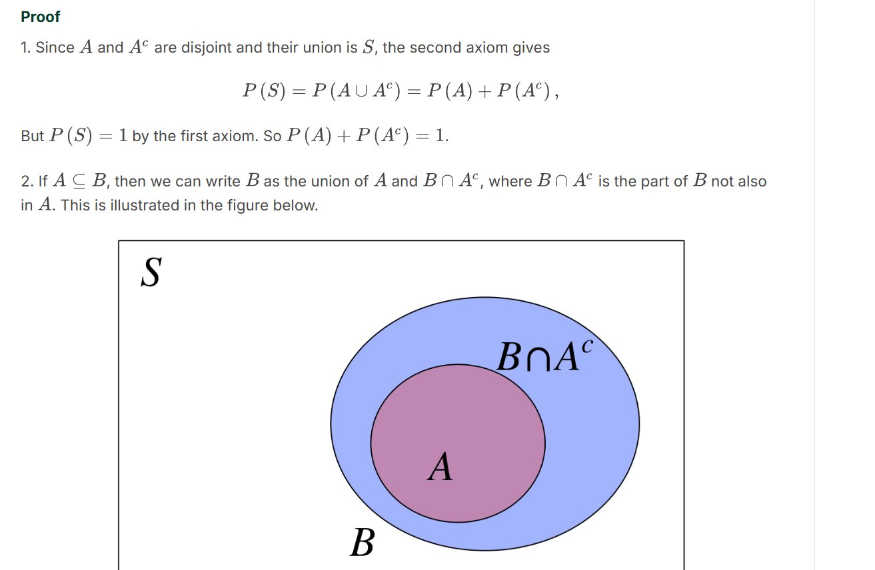

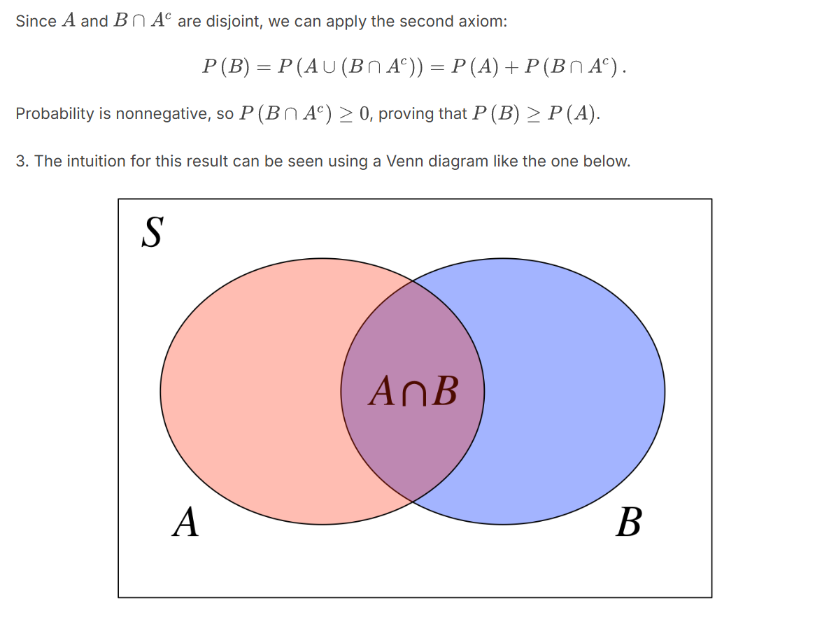
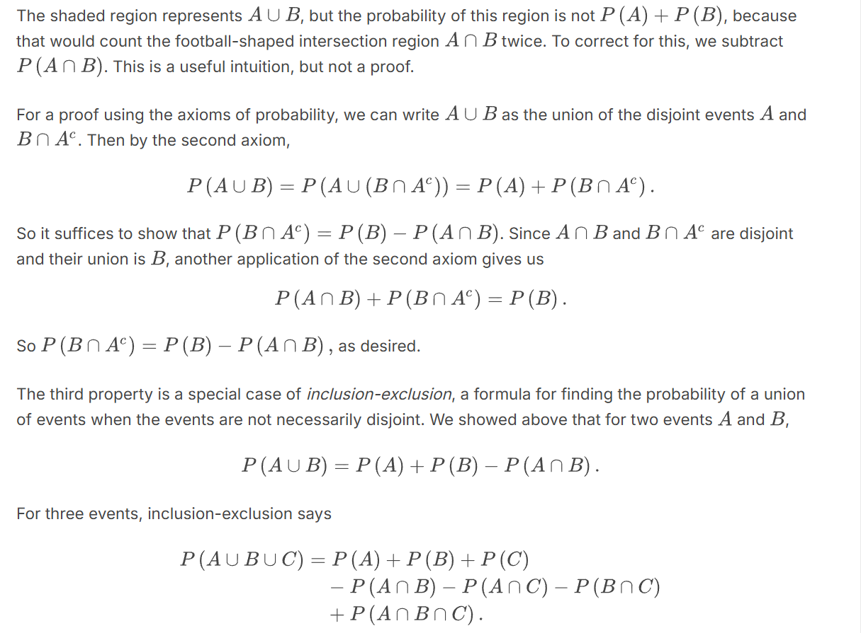
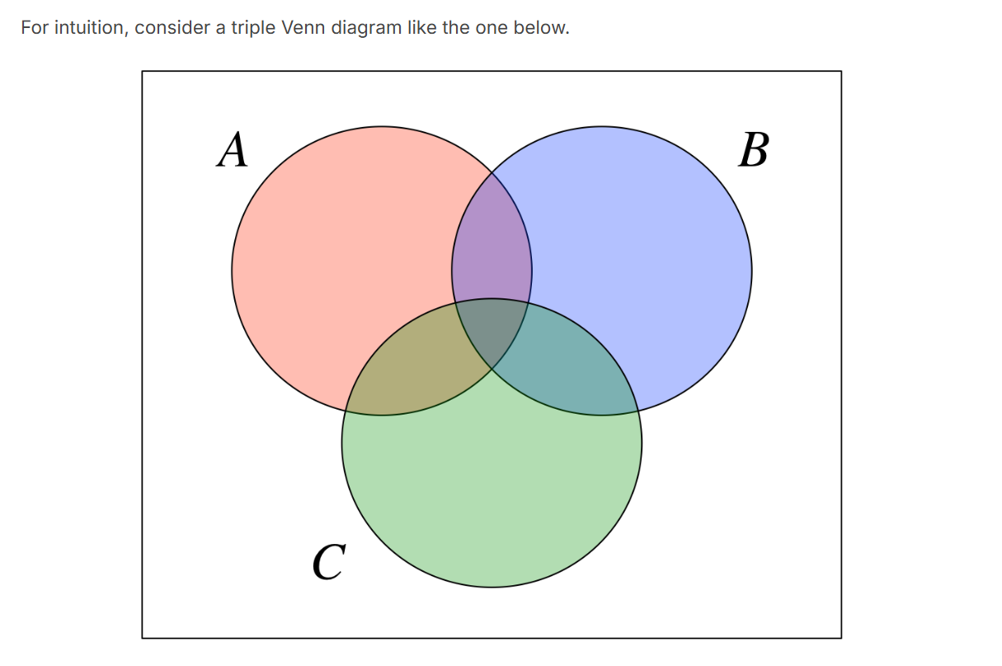
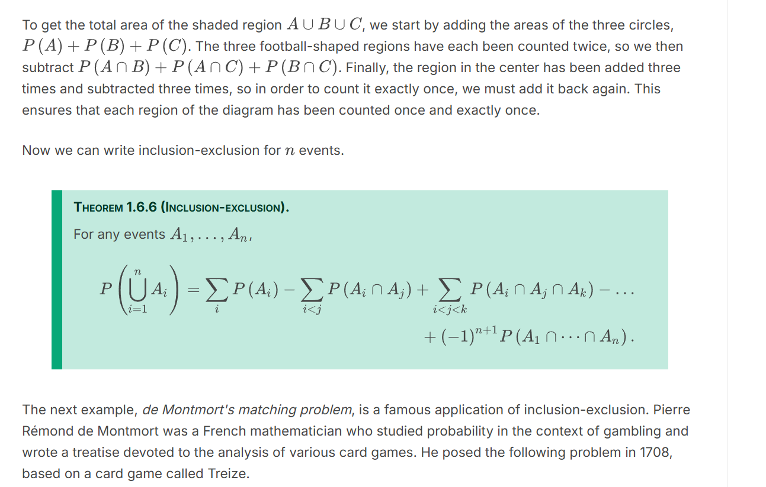

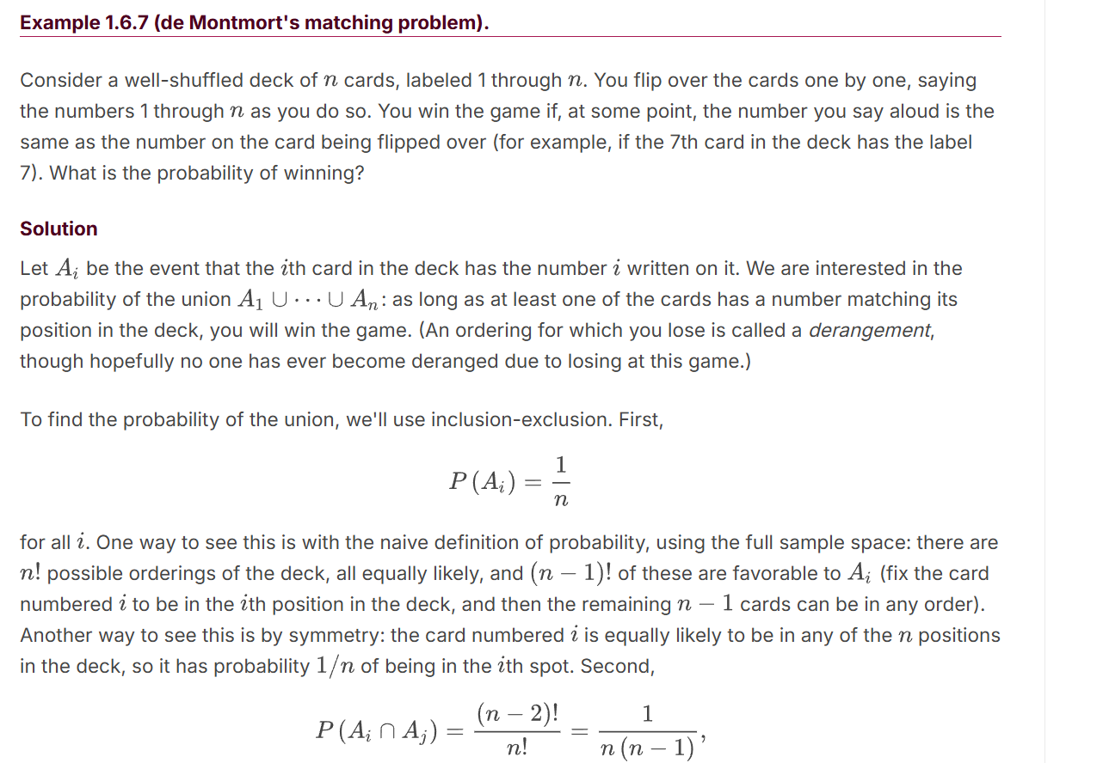
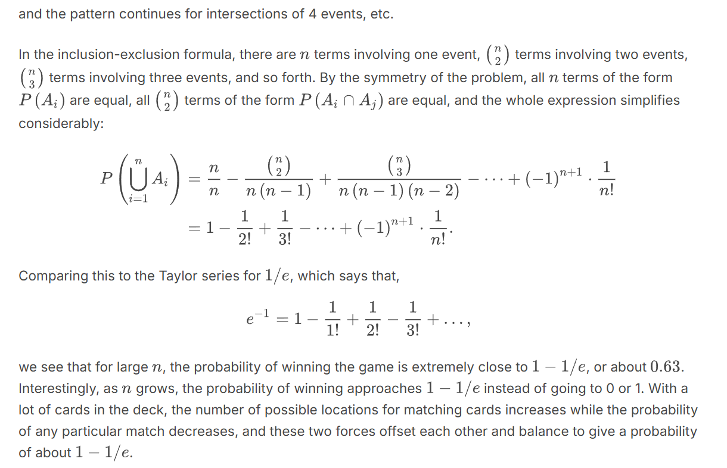
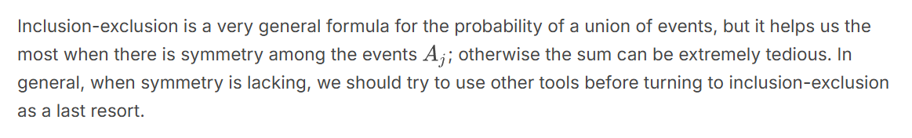

This interactive simulates the birthday problem.
Birthday Problem Simulation - Directions for Use
- Use the slider to select a number of people to add to your room.
- Click "Add" to put them in the room. Click "Stop" to stop adding people to the room and stop the simulation.
- If you want to start over from the beginning, click "Reset Simulation".
What You'll Notice:
- The probability that the next person you add will have the same birthday as at least one of the people who are already present (conditional on the birthdays of everyone already present).
- The (unconditional) probability that, for this room count, there is at least one pair of people with the same birthday.
- Graphical and textual indications of when everyone's birthdays are, and how many people share that birthday.
- A count of the number of people in the room.
- How many people it took to get the first match, second match, and third match (once these occur).
You Should Try:
- What is the probability of at least one match with 10 people? 23? 50? 100? 365?
- How many people does it take to absolutely guarantee a match?
- How much variability does there seem to be in when the first match appears? What about the second match?

